- Program ID : VA006MA1

- Display Layout
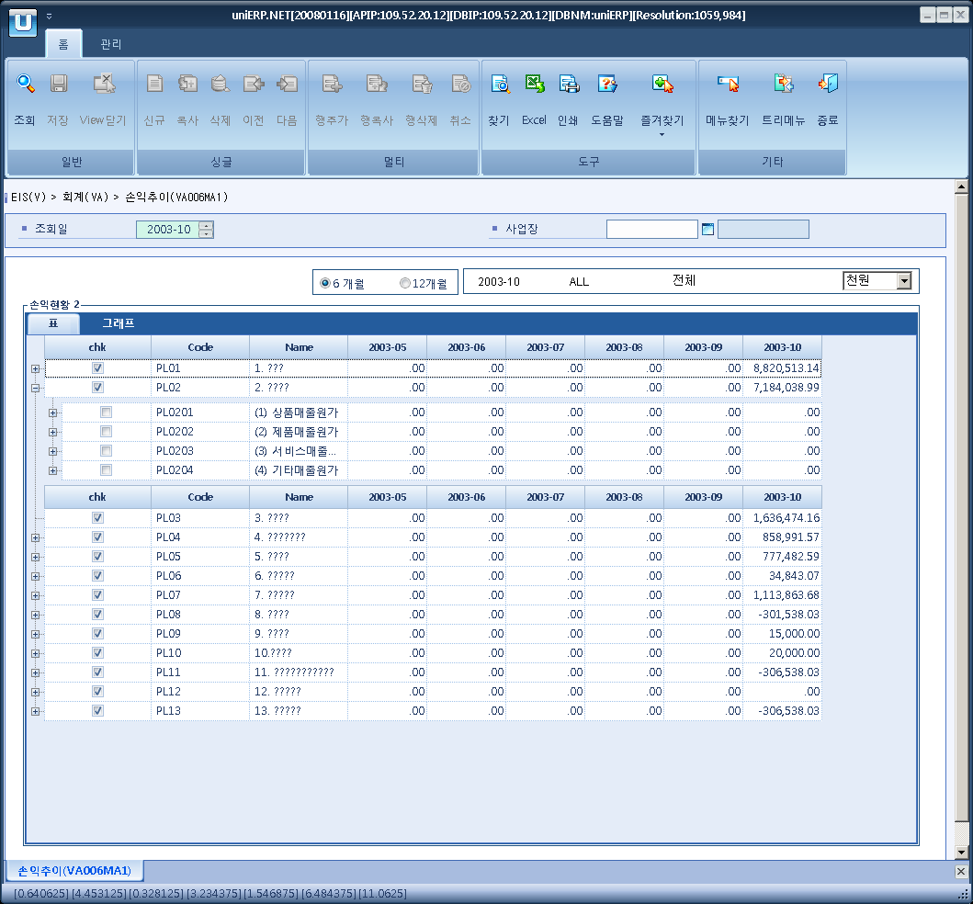

- Event flow
- Click Query button
- OnFncQuery -> DbQuery -> DataChange
- Display Unit combo change
- uniCombo1_ValueChanged -> DataChange

- SQL Statements
- Profit and Loss
WITH BSHire(lvl_cd1, lvl_nm1, lvl_cd2, lvl_nm2, lvl_cd3, lvl_nm3, lvl_cd4, lvl_nm4,
lvl_cd5, lvl_nm5, lvl_cd6, lvl_nm6, lvl_cd7, lvl_nm7, lvl_cd8, lvl_nm8,
bal_fg, class_lvl, class_seq, class_cd, class_nm, group_cd, acct_cd, sort)
AS (SELECT class_cd, class_nm,
CONVERT(VARCHAR(20), NULL), CONVERT(VARCHAR(50), NULL), CONVERT(VARCHAR(20), NULL), CONVERT(VARCHAR(50), NULL),
CONVERT(VARCHAR(20), NULL), CONVERT(VARCHAR(50), NULL), CONVERT(VARCHAR(20), NULL), CONVERT(VARCHAR(50), NULL),
CONVERT(VARCHAR(20), NULL), CONVERT(VARCHAR(50), NULL), CONVERT(VARCHAR(20), NULL), CONVERT(VARCHAR(50), NULL),
CONVERT(VARCHAR(20), NULL), CONVERT(VARCHAR(50), NULL),
bal_fg, class_lvl, class_seq, class_cd, class_nm,
class_cd AS group_cd, CONVERT(VARCHAR(20), '*') AS acct_cd,
CONVERT(varchar(255), CONVERT(varchar(5), class_lvl) + REPLICATE('0', 3 - DATALENGTH(CONVERT(varchar(5), class_seq))) + CONVERT(varchar(5), class_seq))
FROM a_acct_class
WHERE class_type = 'PL'
AND class_lvl = 1
UNION ALL
SELECT a.lvl_cd1, a.lvl_nm1,
CASE a.class_lvl + 1 WHEN 2 THEN b.class_cd ELSE a.lvl_cd2 END,
CASE a.class_lvl + 1 WHEN 2 THEN b.class_nm ELSE a.lvl_nm2 END,
CASE a.class_lvl + 1 WHEN 3 THEN b.class_cd ELSE a.lvl_cd3 END,
CASE a.class_lvl + 1 WHEN 3 THEN b.class_nm ELSE a.lvl_nm3 END,
CASE a.class_lvl + 1 WHEN 4 THEN b.class_cd ELSE a.lvl_cd4 END,
CASE a.class_lvl + 1 WHEN 4 THEN b.class_nm ELSE a.lvl_nm4 END,
CASE a.class_lvl + 1 WHEN 5 THEN b.class_cd ELSE a.lvl_cd5 END,
CASE a.class_lvl + 1 WHEN 5 THEN b.class_nm ELSE a.lvl_nm5 END,
CASE a.class_lvl + 1 WHEN 6 THEN b.class_cd ELSE a.lvl_cd6 END,
CASE a.class_lvl + 1 WHEN 6 THEN b.class_nm ELSE a.lvl_nm6 END,
CASE a.class_lvl + 1 WHEN 7 THEN b.class_cd ELSE a.lvl_cd7 END,
CASE a.class_lvl + 1 WHEN 7 THEN b.class_nm ELSE a.lvl_nm7 END,
CASE a.class_lvl + 1 WHEN 8 THEN b.class_cd ELSE a.lvl_cd8 END,
CASE a.class_lvl + 1 WHEN 8 THEN b.class_nm ELSE a.lvl_nm8 END,
ISNULL(b.bal_fg, a.bal_fg), CONVERT(smallint, a.class_lvl + 1),
b.class_seq, b.class_cd, b.class_nm,
CASE WHEN b.class_cd = b.acct_cd THEN a.class_cd ELSE b.class_cd END AS group_cd,
CASE WHEN b.class_cd = b.acct_cd THEN b.acct_cd ELSE '*' END AS acct_cd,
CONVERT(VARCHAR(255), RTRIM(Sort) + '|' + CONVERT(VARCHAR(5), a.class_lvl + 1) + REPLICATE('0', 3 - DATALENGTH(CONVERT(varchar(5), ISNULL(b.class_seq, a.class_seq)))) + CONVERT(varchar(5), ISNULL(b.class_seq, a.class_seq)))
FROM BSHire AS a
JOIN (SELECT par_class_cd, class_cd, class_nm, class_seq, bal_fg, '*' AS acct_cd
FROM a_acct_class
WHERE class_type = 'PL'
AND class_lvl > 1
AND class_cd <> par_class_cd
UNION ALL
SELECT a.class_cd AS par_class_cd, a.acct_cd AS class_cd,
b.acct_nm AS class_nm, NULL AS class_seq, NULL, a.acct_cd
FROM a_clssfc_of_acct a
INNER JOIN a_acct b
ON b.acct_cd = a.acct_cd
WHERE a.class_type = 'PL') AS b
ON a.class_cd = b.par_class_cd )
SELECT a.lvl_cd1 + '|' + a.lvl_nm1 AS lvl1, a.lvl_cd2 + '|' + a.lvl_nm2 AS lvl2,
a.lvl_cd3 + '|' + a.lvl_nm3 AS lvl3, a.lvl_cd4 + '|' + a.lvl_nm4 AS lvl4,
a.lvl_cd5 + '|' + a.lvl_nm5 AS lvl5,
CASE WHEN a.lvl_cd2 + '|' + a.lvl_nm2 IS NULL THEN 1
ELSE CASE WHEN a.lvl_cd3 + '|' + a.lvl_nm3 IS NULL THEN 2
ELSE CASE WHEN a.lvl_cd4 + '|' + a.lvl_nm4 IS NULL THEN 3
ELSE CASE WHEN a.lvl_cd5 + '|' + a.lvl_nm5 IS NULL THEN 4
ELSE 5
END
END
END
END AS lvl,
ISNULL(SUM(b.sum12), 0) AS sum12, ISNULL(SUM(b.sum11), 0) AS sum11, ISNULL(SUM(b.sum10), 0) AS sum10,
ISNULL(SUM(b.sum9), 0) AS sum9, ISNULL(SUM(b.sum8), 0) AS sum8, ISNULL(SUM(b.sum7), 0) AS sum7,
ISNULL(SUM(b.sum6), 0) AS sum6, ISNULL(SUM(b.sum5), 0) AS sum5, ISNULL(SUM(b.sum4), 0) AS sum4,
ISNULL(SUM(b.sum3), 0) AS sum3, ISNULL(SUM(b.sum2), 0) AS sum2, ISNULL(SUM(b.sum1), 0) AS sum1,
MIN(a.sort) AS sort
FROM BSHire a
LEFT MERGE JOIN (SELECT bs_pl_flag, acct_cd,
SUM(CASE WHEN yyyymm = SUBSTRING(CONVERT(VARCHAR, DATEADD(month, -11, @strYear + @strMonth + '01'), 112), 1, 6) THEN amt ELSE 0 END) AS sum12,
SUM(CASE WHEN yyyymm = SUBSTRING(CONVERT(VARCHAR, DATEADD(month, -10, @strYear + @strMonth + '01'), 112), 1, 6) THEN amt ELSE 0 END) AS sum11,
SUM(CASE WHEN yyyymm = SUBSTRING(CONVERT(VARCHAR, DATEADD(month, -9, @strYear + @strMonth + '01'), 112), 1, 6) THEN amt ELSE 0 END) AS sum10,
SUM(CASE WHEN yyyymm = SUBSTRING(CONVERT(VARCHAR, DATEADD(month, -8, @strYear + @strMonth + '01'), 112), 1, 6) THEN amt ELSE 0 END) AS sum9,
SUM(CASE WHEN yyyymm = SUBSTRING(CONVERT(VARCHAR, DATEADD(month, -7, @strYear + @strMonth + '01'), 112), 1, 6) THEN amt ELSE 0 END) AS sum8,
SUM(CASE WHEN yyyymm = SUBSTRING(CONVERT(VARCHAR, DATEADD(month, -6, @strYear + @strMonth + '01'), 112), 1, 6) THEN amt ELSE 0 END) AS sum7,
SUM(CASE WHEN yyyymm = SUBSTRING(CONVERT(VARCHAR, DATEADD(month, -5, @strYear + @strMonth + '01'), 112), 1, 6) THEN amt ELSE 0 END) AS sum6,
SUM(CASE WHEN yyyymm = SUBSTRING(CONVERT(VARCHAR, DATEADD(month, -4, @strYear + @strMonth + '01'), 112), 1, 6) THEN amt ELSE 0 END) AS sum5,
SUM(CASE WHEN yyyymm = SUBSTRING(CONVERT(VARCHAR, DATEADD(month, -3, @strYear + @strMonth + '01'), 112), 1, 6) THEN amt ELSE 0 END) AS sum4,
SUM(CASE WHEN yyyymm = SUBSTRING(CONVERT(VARCHAR, DATEADD(month, -2, @strYear + @strMonth + '01'), 112), 1, 6) THEN amt ELSE 0 END) AS sum3,
SUM(CASE WHEN yyyymm = SUBSTRING(CONVERT(VARCHAR, DATEADD(month, -1, @strYear + @strMonth + '01'), 112), 1, 6) THEN amt ELSE 0 END) AS sum2,
SUM(CASE WHEN yyyymm = @strYear + @strMonth THEN amt ELSE 0 END) AS sum1
FROM (SELECT bs_pl_flag, acct_cd, yyyymm, ISNULL(bs_pl_amt, 0) AS amt
FROM vb000bt
WHERE yyyymm BETWEEN CONVERT(VARCHAR(6), DATEADD(month, -11, @strYear + @strMonth + '01'), 112)
AND @strYear + @strMonth
AND biz_area_cd = @strBizArea
AND class_type = 'PL') a
GROUP BY bs_pl_flag, acct_cd) b
ON b.bs_pl_flag = a.group_cd
AND b.acct_cd = a.acct_cd
-- WHERE a.class_cd < 'PL'
GROUP BY a.lvl_cd1 + '|' + a.lvl_nm1, a.lvl_cd2 + '|' + a.lvl_nm2,
a.lvl_cd3 + '|' + a.lvl_nm3, a.lvl_cd4 + '|' + a.lvl_nm4,
a.lvl_cd5 + '|' + a.lvl_nm5
HAVING a.lvl_cd1 + '|' + a.lvl_nm1 IS NOT NULL
ORDER BY sort, a.lvl_cd1 + '|' + a.lvl_nm1, a.lvl_cd2 + '|' + a.lvl_nm2,
a.lvl_cd3 + '|' + a.lvl_nm3, a.lvl_cd4 + '|' + a.lvl_nm4,
a.lvl_cd5 + '|' + a.lvl_nm5

